Year Group: Year 1
Strand: Numbers
Topic: Place value
Learning Objective: Begin to partition two-digit numbers into tens and ones
Strategy
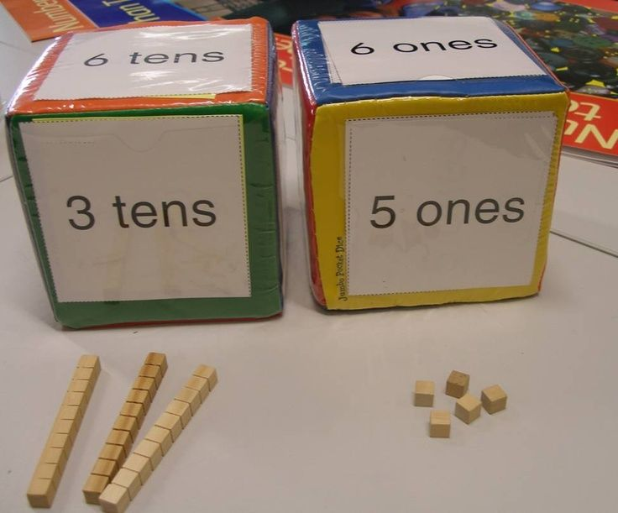
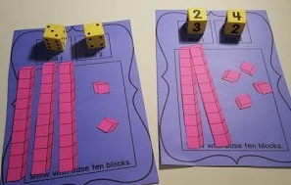
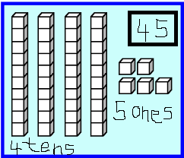

Partitioning:
 | Tens | Ones
45 | 4 | 5
12 | 1 | 2
28 | 2 | 8

Extra Worksheets

