**Year Group: 2**

**Strand: Measurement**

**Topic: Measures and Problem solving**

**Learning objectives: To** know the unit of time (seconds, minutes, Hours, days, weeks, Months and years) (2Mt1)

To know the relationship between consecutive units of time. (2Mt2)

To measure activities using seconds and minutes. (2Mt4)

**Strategies**

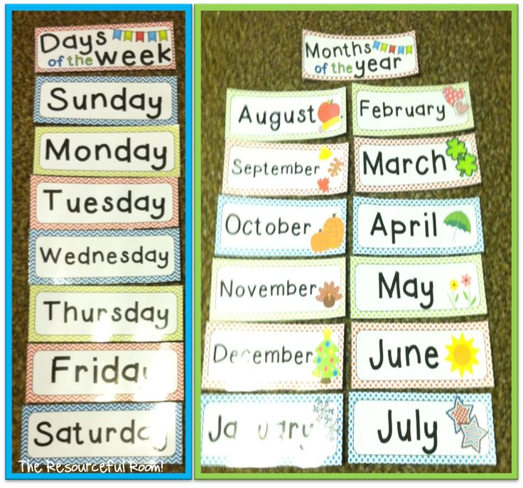

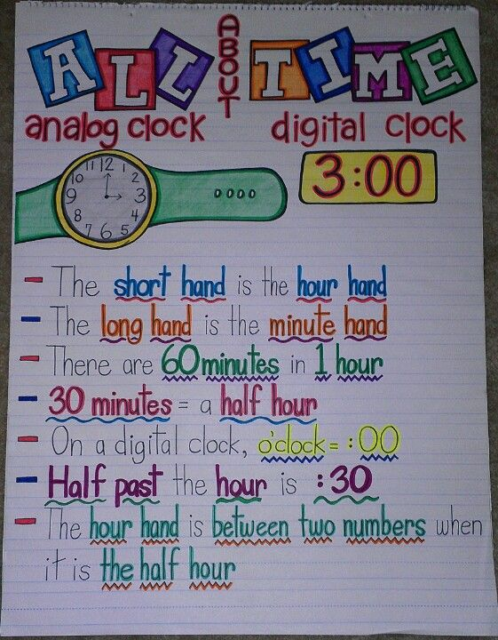

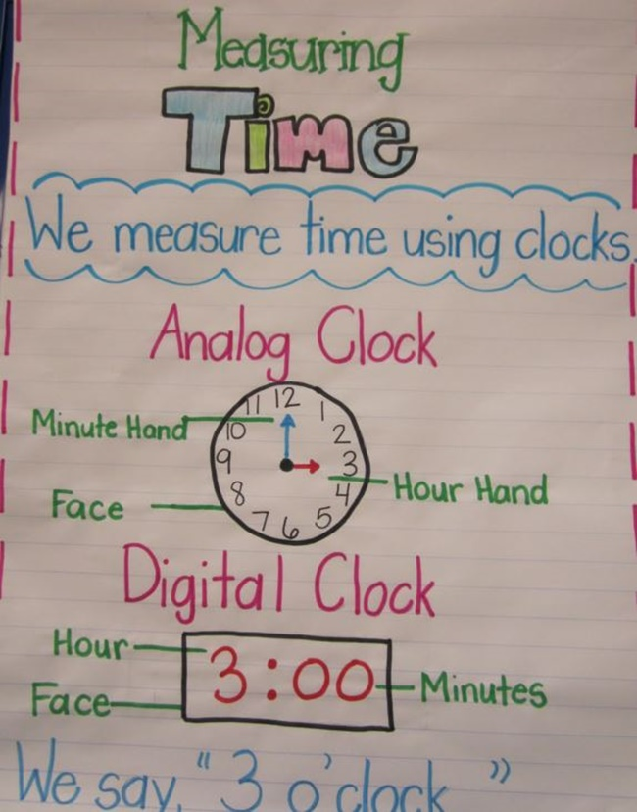

Using the analogue clock to tell time

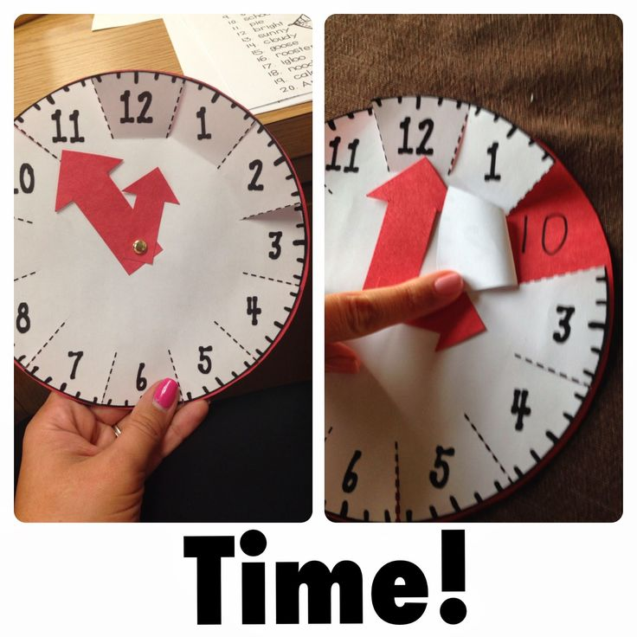

**Worksheets**

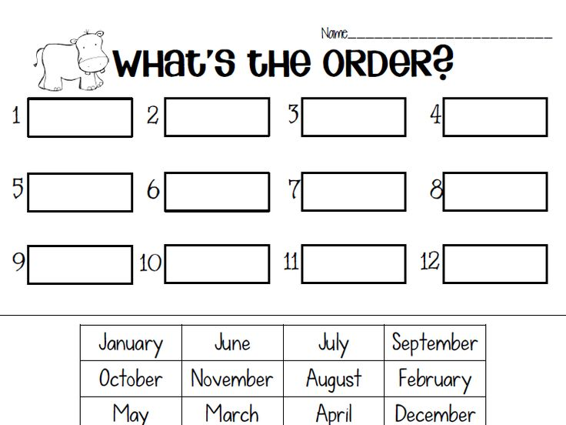

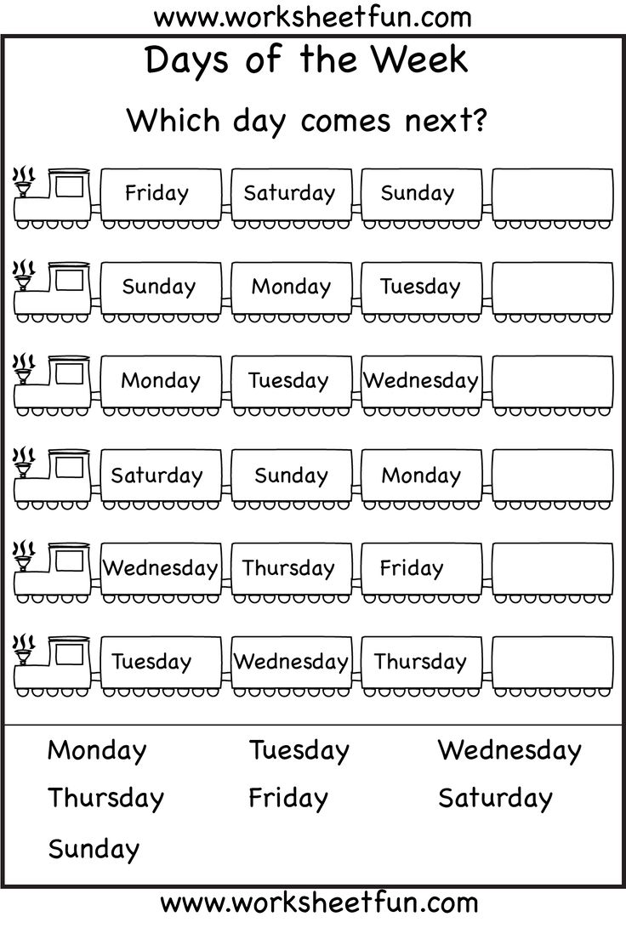

Time Worksheet 1

Write the times underneath each clock.

1 o'clock 9 o'clock 6 o'clock 4 o'clock

12 o'clock 7 o'clock 10 o'clock 3 o'clock

ten thirtythree thirtyfive thirtyeight thirty

one thirty eleven thirty four thirty twelve thirty

**Strand: Number**

**Topic: Number and problem solving**

**Learning Objectives:**

* Counting on in ones and tens from a single- and two-digit numbers and back again. (2Nn3)
* Count in twos, fives or tens to count larger groups of numbers. (2Nn4)
* Explain methods and reasoning orally. (2Pt2)

**Strategy**

**Addition Using the Number Line**

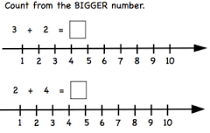

**Strategy**

**Subtraction Using the Number Line**

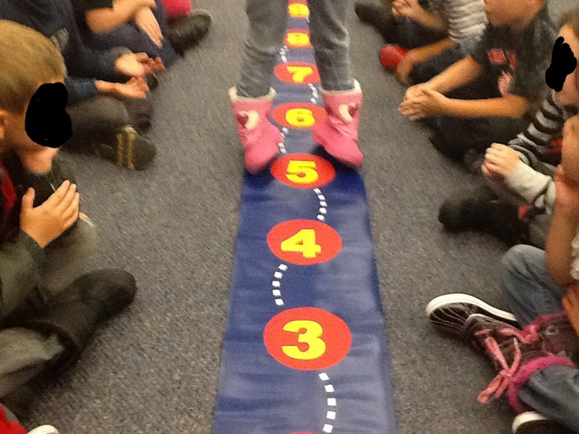

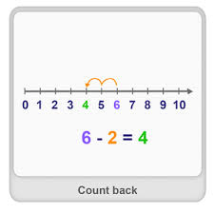

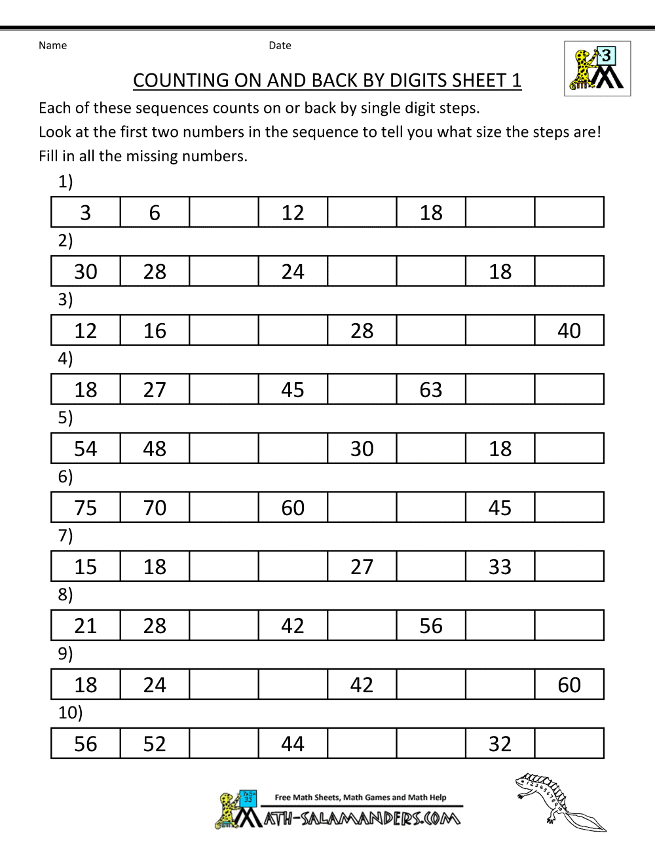

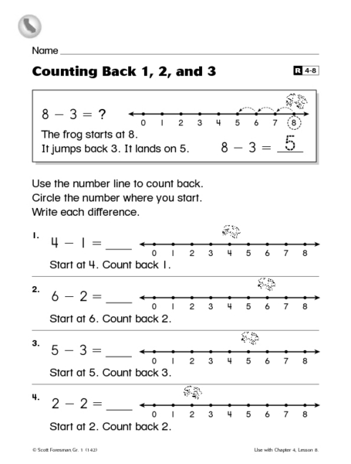

**Strand: Number**

**Topic:** **Multiplication**

**Learning objectives**

* Understand multiplication as repeated addition and use the x sign. (2Nc16)
* Understand multiplication as describing an array (2Nc17)
* Learn and recognize multiples of 2,5, and 10. (2Nc4)
* Make sense of simple word problem. (2Pt4)

Strategies

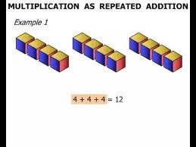 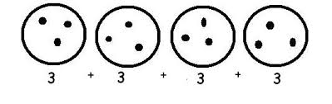

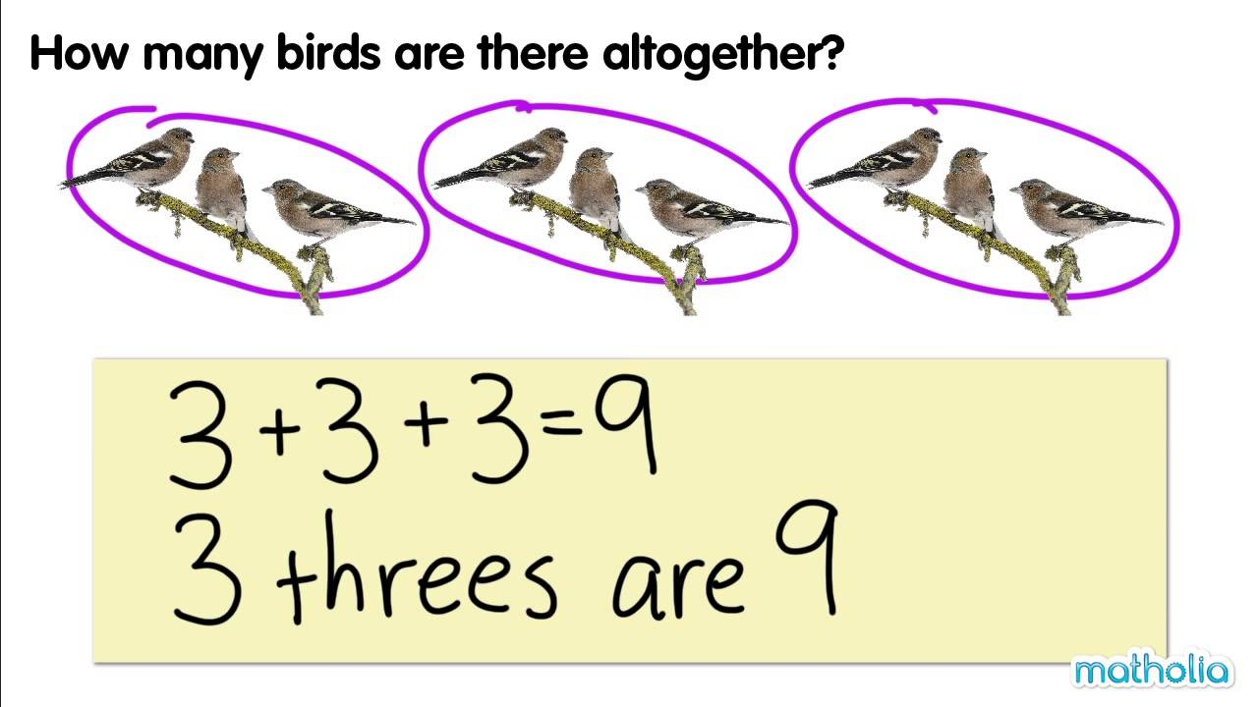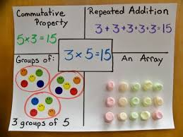 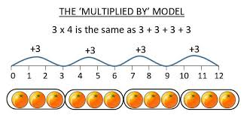

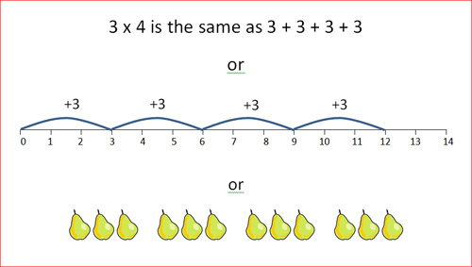 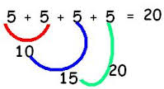

Worksheet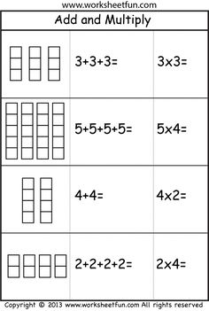ets

**Strand: Number**

**Topic:** **Number Pairs**

**Learning objectives;**

* Find and learn by heart all number pairs to 10 and pairs with a total of 20. (2Nc1)
* Explain methods and reasoning orally. (2Pt2)

**Strategies**

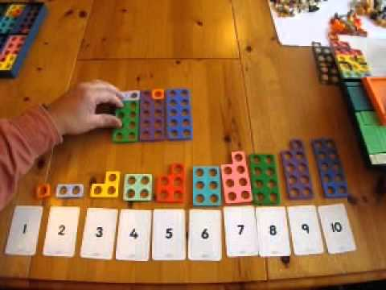

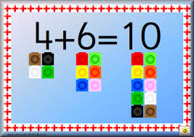 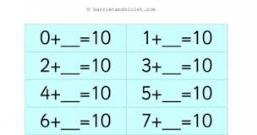

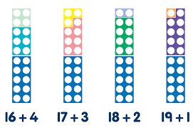

**Strand: Number**

**Topic:** **Addition and subtraction**

**Learning objectives;**

* Add and subtract a single digit to and from a two digit number. (2Nc11)
* Choose appropriate mental strategies to carry out calculations and explain how they worked out the answer. (2Pt1)
* Make sense of simple word problems. (2Pt4)

Strategies

